HONOR YOUR ATHLETE WITH A MEMORIAL BRICK IN THE PARKLAND TROJAN ALUMNI VARSITY CLUB ATHLETE MEMORIAL
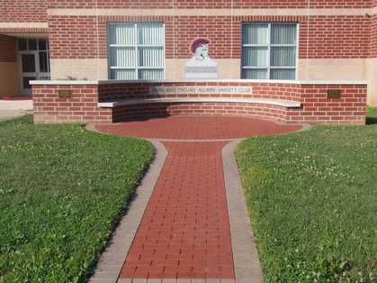
The Memorial is located outside of Parkland High School
A brick will memorialize your athlete for years to come. Bricks make great birthday or graduation gifts.
Cost: $60/ brick
Bricks may be ordered at any time but they will not be placed in memorial until end of school year when all classes finish.
Custom engraved with three lines – 12 characters per line (Space is considered a character)
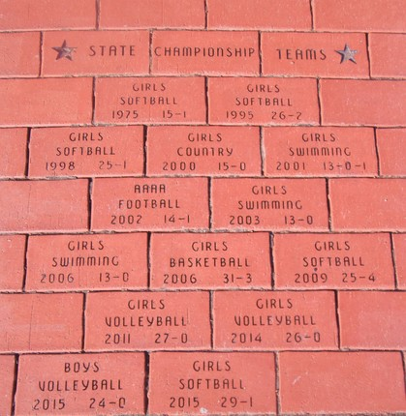

Ordered by:
Name:
Address:
Phone:
Checks payable to: TAVC Send to: Richard Trumbauer
9230 Newtown Road
Breinigsville, PA 18031
Parkland Trojan Alumni Varsity Club reserves the right to reject any inappropriate submission for brick engraving.

